***LINUX DAY 1***

1. ***ADMINISTATOR***



**# →**this symbol is used for only adminuser

**~ →**this symbol was indicate root



$ →this symbol is used for only otheruser

1. **ADDING USER**

**Command --> useradd gokul**



1. **SWITCHING USER**

**Command --> su gokul**

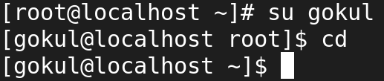

1. **LOGOUT FROM OTHERUSER**

**COMMAND** --> **exit**

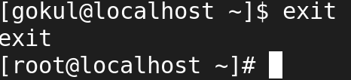

1. **/ command**

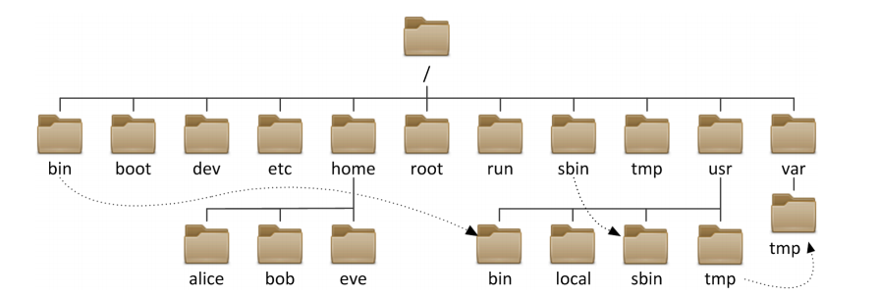

1. **CREATING NEW DIRECTORY (FOLDER)**

**COMMAND ---> mkdir (directory name)**



1. **Viewing new directory**

**Command ---> ls**



1. **Viewing all directory with detail**

**Command ---> ls -l**

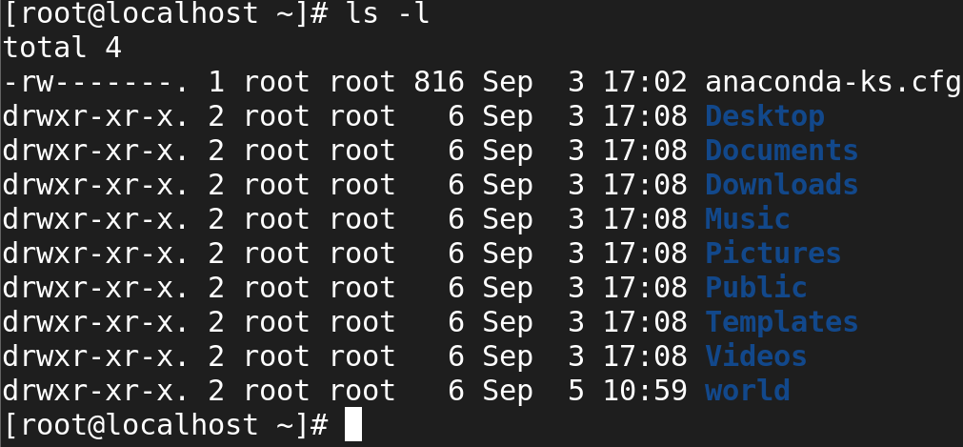

Command ----> **ls man**

This command can used to viwe all optional command

1. **CHANGE DIRECTORY**

**COMMAND ---> cd world**

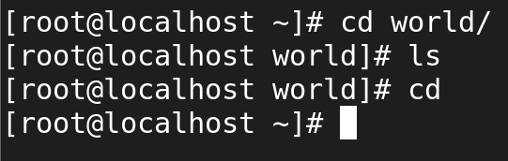

**cd ../ - move to the parent directory**

**cd ../..**

**cd - - will change the user to the old directory.**

**cd - move to user home diretory**

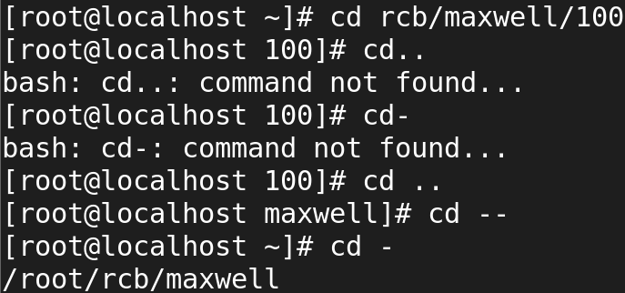

1. **Present working directory**

**Command --->pwd**

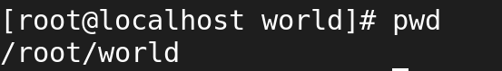

1. **CREATING MULTIPLE DIRECTORY AT SAME TIME**

**Command ---> mkdir ( opt1 opt2 opt3)**

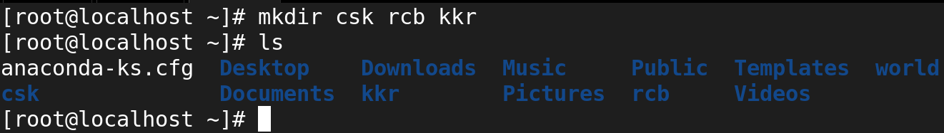

**Command ---> mkdir opt{1..5}**



1. **CREATING PARENT DIR & CHILD DIR**

**COMMAND --> mkdir -p dad/child1/child2**

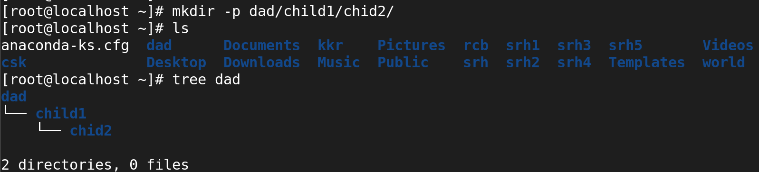

Tree command is used to view all child dir inside the parent dir

1. **Remove Diroctory**



“rmdir” it just remove empty directory without any permissions



As the man dir is not empty, we simply can’t remove

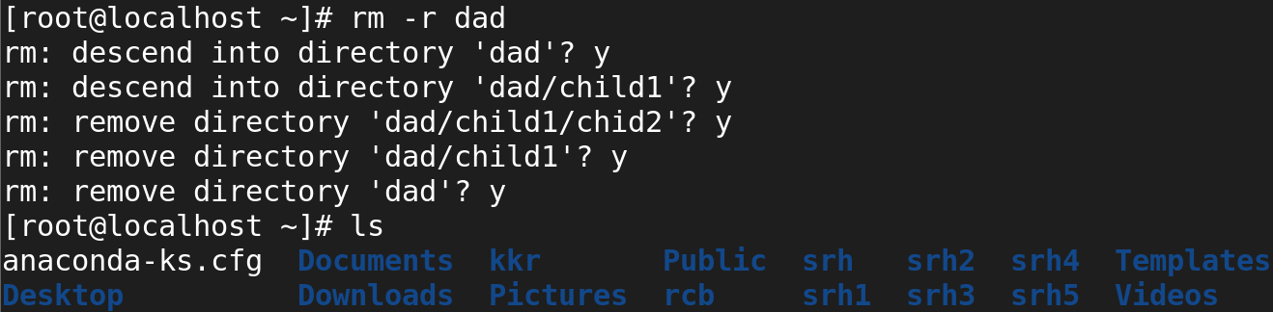

-r removes with request

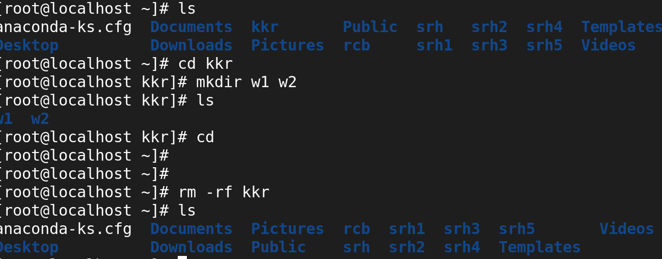

-rf remove forcefully without permissions

1. **Relative path**

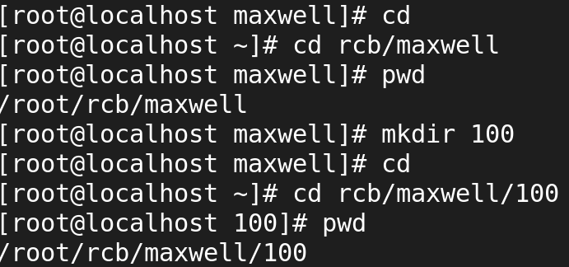

1. **Absolute path**

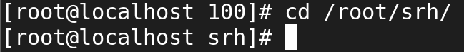

To enter another dir from the current dir

1. **To viwe date & calender**

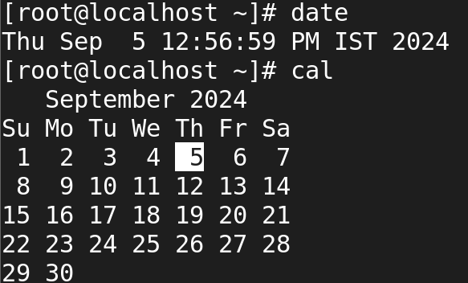

To viwe time and reverse order in ls

**Command ---> ls -lt , ls -lr**

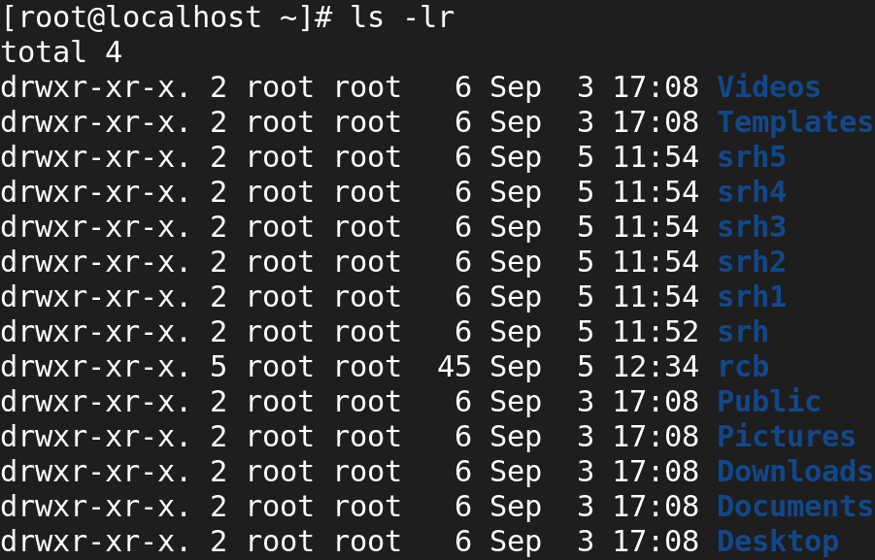

#### To **create** a file

#### **Command ---> touch (file name)**



To create multiple file at same time

**Command ---> Touch ram ram1 ram2**

**Touch dad{1..5}**

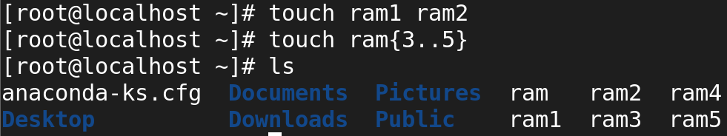

1. **CAT COMMAND**

It used to read and write file

**Command ---> cat file(to viwe)**

**Cat > file (to write )**

**Cat >> file (to overwrite)**

Ctrl c is used to exit the file

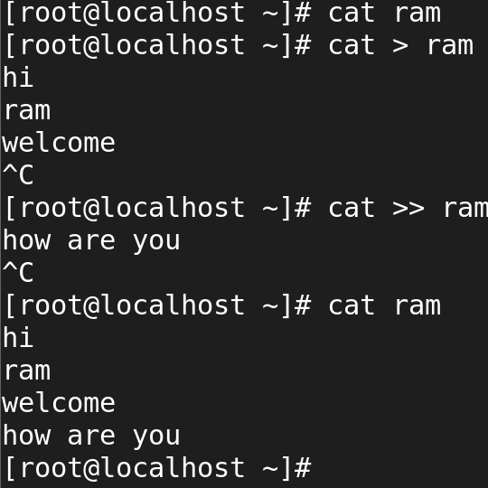

1. **Copy command**

Command ----> **cp source destination**

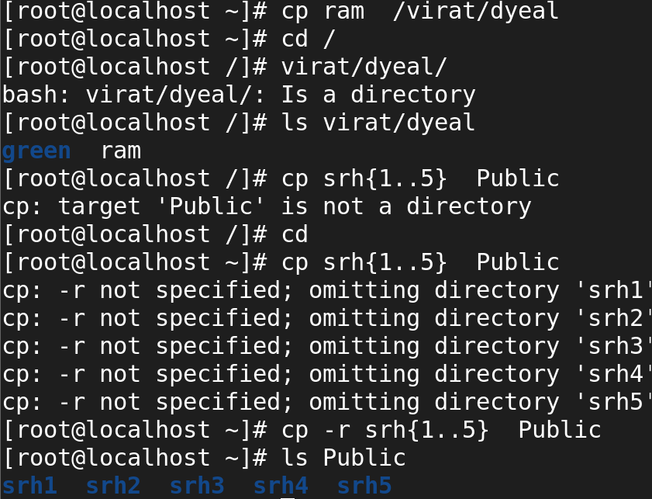

* It is used to copy multiple files
* It is used to copy file to directory . all are shown in above fig.

1. **Move file**

Command --> mv source directory

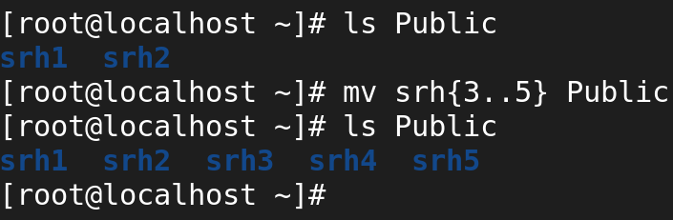

Command ---> mv (file)to (dir)

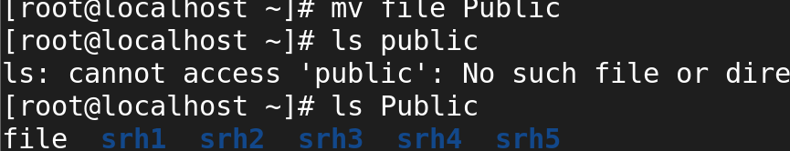

Rename the file name.

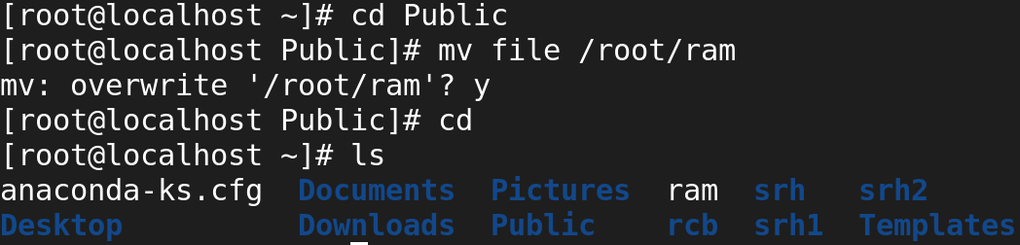

Rename the directory name.

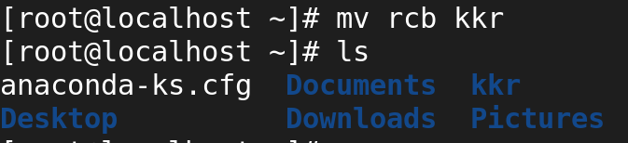

**LIST**

1. **Hidden Files**

* -la 🡺 It is used to long list the hidden files.
* -a 🡺 It is used to list the hidden files.

1. **I node Number**

* -i 🡺 i node number.
* -li 🡺 long list i node number.
* -iR 🡺 i node number with Tree Stucture

1. **Particular Directory**

* -d 🡺 To view Particular Directory.
* -ld 🡺 To long list Particular Directory.

1. **Reverse List**

* -r 🡺 To list out in reverse order.
* -lr 🡺 To long list in reverse order.

1. **Tree Stucture**

* -R 🡺 To view directory in Tree order.
* -lR 🡺 To Long list directory and Tree order.

1. **Human Readable Format**

* - lh 🡺 To view in human readable format

**FALLOCATE**

Allocate certain file size to particular file

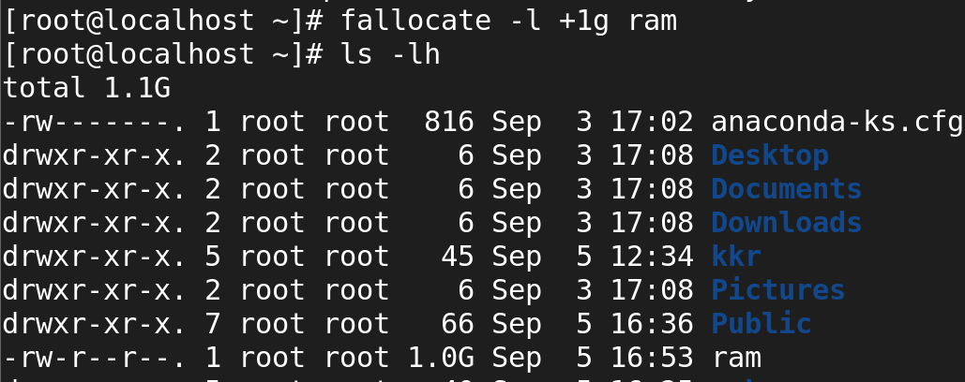

**IDENTYFY IP**

* If config (or) ip a 🡺 To identify the IP of your device
* **Example:**
* ip a, ifconfig

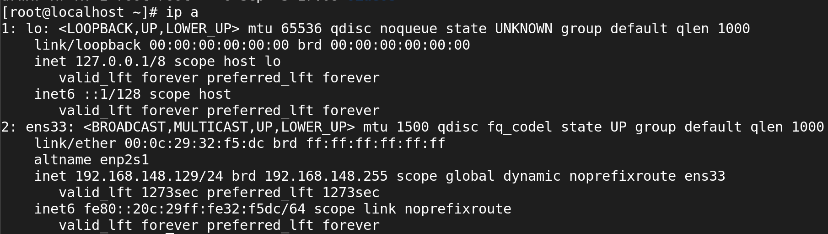

**Command |grep**

* To search particular word

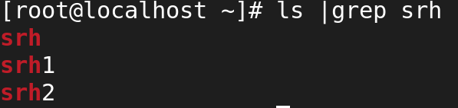

* To search particular word with no of the line

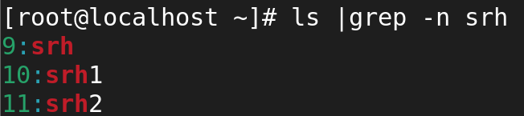

**TO VIEW PARAGRAPH**

* cat _file name_|less

**example:** cat sample|less

* cat _file name_|more

**example:** cat sample|more

* cat _file name_|head

**example:** cat sample|head

* cat _file name_|head -2

**example:** cat sample|head -2

* cat _file name_|tail

**example:** cat sample|tail

* cat _file name_|tail -2

**example:** cat sample|tail­ -2